* **1. What are the main components of software cost / Parameter to compute total cost of software development?**
* **Answer:**
* Hardware and software costs (including maintenance).
* Travel and training costs.
* Effort costs (like salaries, social and insurance costs).
* Overhead costs like building, lighting, networking, and shared facilities.
* **2.**What are the main factors that affect software pricing**?**
* **Answer:**
* **Market Opportunity:** Prices may be kept low to enter new markets.
* **Unclear Costs:** Extra cost is added if it’s hard to guess the total expense.
* **Contract Rules:**Price can change depending on who owns the software.
* **Changing Needs:**f customer needs change later, prices may go up.
* **Company’s Money Situation:** A company in financial trouble might offer lower prices to win projects.
* **3. What is software cost estimation / Estimation Techniques?**
* **Answer:** Estimation tells us how much money, time, and resources will be needed to build a system or product.
* **It is based on: -**
* Past data/experience
* Available documents/knowledge
* Assumptions
* Identified risks
* **4. What is algorithmic cost modeling / Process of algorithm cost modelling?**
* **Answer:** It is a mathematical method to estimate software costs using project size, team size, and other attributes.
* **Formula:**
* Effort = A ∗Size^B ∗ M
* A is a constant.
* Size is the software size (in LOC, function points, etc.).
* B is an exponent (usually 1 to 1.5).
* M is a multiplier based on project and team attributes.
* **5. What are the difficulties of algorithmic cost models?**
* Answer:
* 1. Size is hard to estimate early—code size or function points may be inaccurate.
* 2. B and M are subjective—different people give different values based on experience and system type.
* **1. What is COCOMO?**
* COCOMO is a model used to estimate the time and effort needed to build software.
* **2. What does COCOMO estimate?**
* It estimates:
* Effort (how many people and months)
* Time (how long to finish the project)
* **3. What inputs does COCOMO need?**
* Size of software (in KLOC – 1000 lines of code)
* Project type
* Cost drivers (things that affect productivity)
* **5. What are the 3 project types in COCOMO / Where COCOMO model applied?**
* **Organic:**
* Simple project
* Small team
* Experienced people
* **Semidetached:**
* Medium difficulty
* Mixed team (some new, some experienced)
* **Embedded:**
* Very complex
* Tied to hardware
* Strict rules
* **6. What is the formula used in the Basic COCOMO model?**
* Effort (PM) = a × (KLOC)^b
* Development Time (Tdev) = c × (Effort)^d
* **Example Problem**

7**. A project is estimated to be 400 KLOC. Calculate effort and development time for all three modes.**

* **Let’s use the formulas:**
* Effort = a × (KLOC)^b
* Tdev = c × (Effort)^d
* Given: KLOC = 400
* **1. Organic Mode** (a = 2.4, b = 1.05, c = 2.5, d = 0.38)
* Effort = 2.4 × (400)^1.05 ≈ 1286.8 PM
* Tdev = 2.5 × (1286.8)^0.38 ≈ 38.3 months
* **2. Semidetached Mode** (a = 3.0, b = 1.12, c = 2.5, d = 0.35)
* Effort = 3.0 × (400)^1.12 ≈ 2217.2 PM
* Tdev = 2.5 × (2217.2)^0.35 ≈ 43.0 months
* **3. Embedded Mode** (a = 3.6, b = 1.20, c = 2.5, d = 0.32)
* Effort = 3.6 × (400)^1.20 ≈ 4136.0 PM
* Tdev = 2.5 × (4136.0)^0.32 ≈ 47.8 months
* 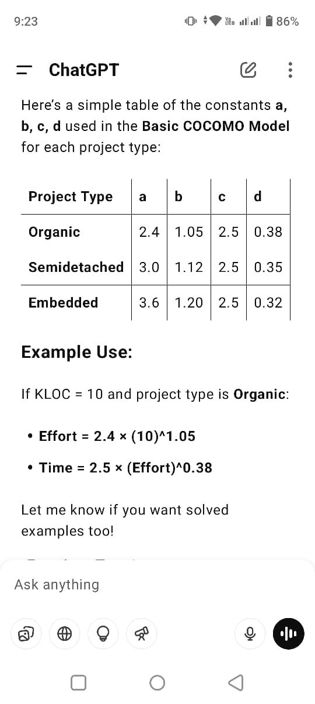

**Extra Question:**

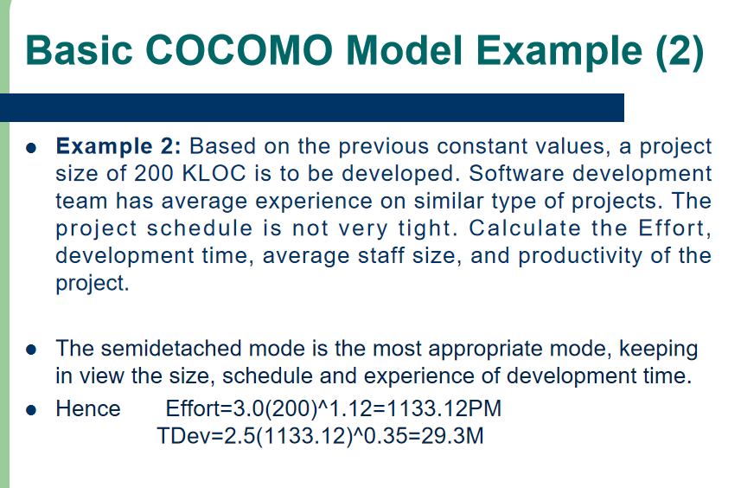

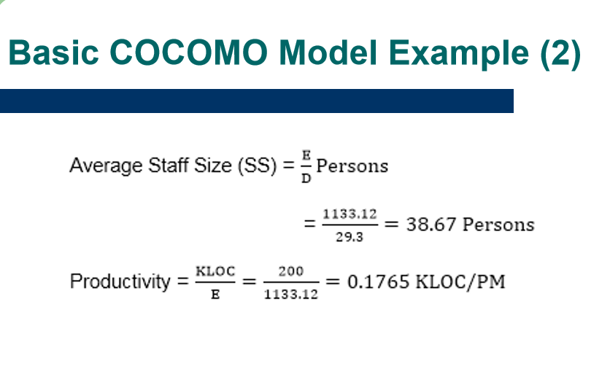

* **Q1: What is the difference between COCOMO 81 and COCOMO II?**
* Ans: COCOMO 81 is for old-style (waterfall) development from scratch. COCOMO II works for modern methods and reuse.
* **Q2: What are the 4 sub-models of COCOMO II / COCOMO 2 sub-model designed,introduced or modified etc ?**
* **Application Composition Model** – Based on reusable components.
* **Early Design Model** – Before design starts.
* **Reuse Model** – For effort needed to reuse software.
* **Post-architecture Model** – After design is available.
* **Q3.What is Software Quality Assurance (SQA) ? (Keyword: Quality assurance,steps of QA,meaning of QA etc etc.)**
* Ans:
* **Makes Sure Software is Good:**
* SQA is a process that checks if the software meets quality rules and works properly.
* **Focuses on the Right Way of Working:**
* It ensures the team follows correct steps and methods while building the software.
* **Stops Problems Early:**
* SQA helps find and fix mistakes early, so they don’t cause bigger issues later.
* **Uses Checks and Reviews:**
* It includes doing code reviews, testing, and audits to keep everything on track.
* **Works in All Project Steps:**
* SQA is used from the beginning of the project to the end, to keep quality high at every stage.
* **Q4: What is Six Sigma?**
* Ans: Six Sigma is a method that uses data and statistics to reduce defects and improve quality.
* **Q5: What are the 3 steps in Six Sigma?**
* Define– Know what the customer wants.
* Measure – Count problems (defects).
* Analyze – Find the main reasons for mistakes.
* **Q6 : Core steps of improve or developed the six sigma.(Keyword: improve six sigma or developed steps of six sigma)**
* Design defect-free process
* Verify process meets needs
* **Q7: What is ISO 9000?**
* ISO 9000 is a set of international standards on quality management and assurance developed to help organizations document and implement an effective quality system.
* **Q8: What are the seven quality management principles of ISO 9000 / Principles of ISO 9000?**
* 1. Customer focus
* 2. Leadership
* 3. Engagement of people
* 4. Process approach
* 5. Improvement
* 6. Evidence-based decision making
* 7. Relationship management
* **Q1: What is SEI CMM model ? Explain the maturity level of CMM model.(Keyword: Maturity level of CMM model with diagram or without diagram)**
* **Definition:** A method to measure the maturity of a software company’s processes (1 to 5 scale).
* Level 1 - **Initial** - Work is performed informally
* Level 2 - **Repeatable** - Work is planned & tracked
* Level 3 - **Defined** - Work is well-defined
* Level 4 - **Managed** - Work is quantitatively controlled
* Level 5 - **Optimizing** - Work is based upon continuous improvement

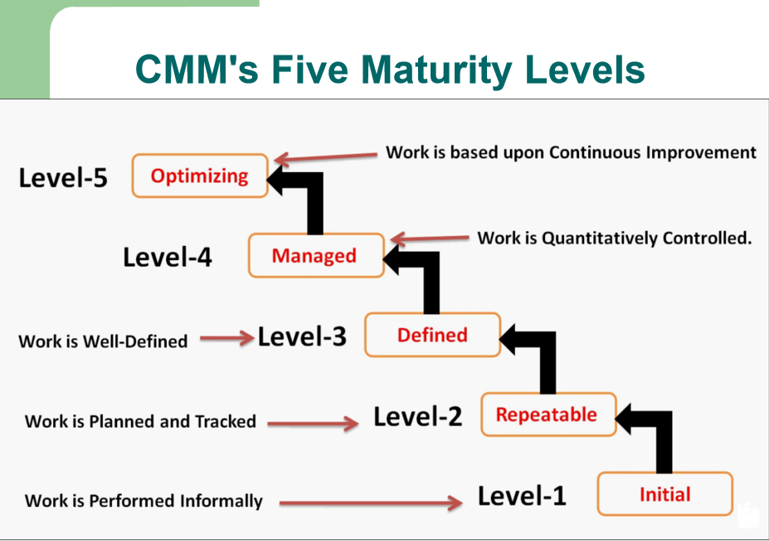

* **Q2: What happens at Level 1 (Initial)?**
* A4: At this level, the work is not planned. Everything depends on people, and there is no proper process. It is full of confusion.
* **Q3: What happens at Level 2 (Repeatable)?**
* A5: The company uses basic planning and management. Good work can be repeated because some processes are written down and followed.
* **Q4: What happens at Level 3 (Defined)?**
* A6: The company has its own standard way of working. The process is written clearly and used by all teams.
* **Q5: What happens at Level 4 (Managed)?**
* A7: The company starts measuring its work using numbers and data. This helps them to manage and control the work better.
* **Q6: What happens at Level 5 (Optimizing)?**
* A8: The company keeps improving its work by using feedback and trying new ideas. It always looks for better ways to do things.
* **Q7: What is the difference in use between ISO 9000 and CMM?**
* A9: ISO 9000 can be used by any company in any industry. CMM is only for software companies.

**Q8 :Difference between ISO 9000 and CMM(ISO 9000 VS CMM) table formet**

